M.Abdullah.Mahmood
BCS-3B
22F-3289
To : Sir saqib
DS LAB 9
Task 2:
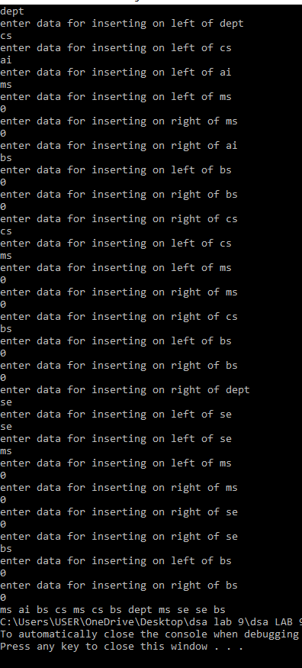
#include <iostream>
using namespace std;

class Btree {
public:
string Data;
Btree* leftChild;
Btree* rightChild;

Btree() {
Data = "";
leftChild = NULL;
rightChild = NULL;
}
Btree(string d) {
Data = d;
leftChild = NULL;
rightChild = NULL;
}

~Btree() {
delete leftChild;
delete rightChild;
}
};

Btree* buildTree() {
string d;
cin >> d;

if (d == "0") {
return NULL;
}

Btree* root = new Btree(d); // Creating a new Btree node

cout << "enter data for inserting on left of " << d << endl;
root->leftChild = buildTree();
cout << "enter data for inserting on right of " << d << endl;
root->rightChild = buildTree();

return root;
}

void inorder(Btree* root) {

if (root == NULL)
return;

inorder(root->leftChild);
cout << root->Data << " ";
inorder(root->rightChild);

}

int main() {
Btree* tre = buildTree();
inorder(tre);

delete tre;

return 0;
}

Task 1:
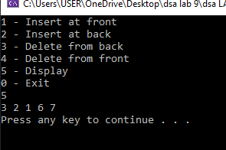
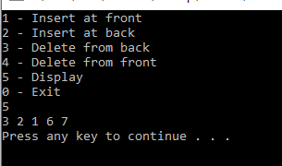
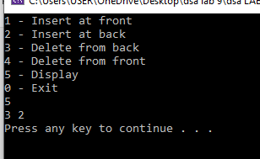
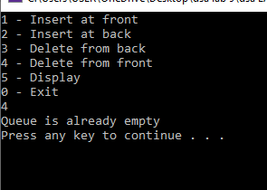
#include <iostream>
using namespace std;

class Dqueue {
private:
int* que;
int front;
int rear;
int MAX_Q; // Maximum size of the queue
int Q_size;

public:
Dqueue(int maxSize) {
MAX_Q = maxSize;
front = rear = -1;
que = new int[MAX_Q];
for (int i = 0; i < MAX_Q; ++i)
que[i] = 0;
}

bool isFull() {
return ((rear + 1) % MAX_Q == front);
}

bool isEmpty() {
return (front == -1 && rear == -1);
}

void insertAt_B(int val) {
if (isFull()) {
cout << "Queue is full" << endl;
return;
}

if (isEmpty()) {
front = 0;
rear = 0;
}
else {
rear = (rear + 1) % MAX_Q;
}

que[rear] = val;
}

void insertAt_F(int val) {
if (isFull()) {
cout << "Queue is full" << endl;
return;
}

if (isEmpty()) {
front = 0;
rear = 0;
}
else {
front = (front - 1 + MAX_Q) % MAX_Q;
}

que[front] = val;
}

void remove_Back() {
if (isEmpty()) {
cout << "Queue is already empty" << endl;
return;
}

int num = que[rear];
que[rear] = 0;

if (front == rear) {
front = rear = -1;
}
else {
rear = (rear - 1 + MAX_Q) % MAX_Q;
}

cout << "Removed " << num << " from the back" << endl;
}

void remove_Fr() {
if (isEmpty()) {
cout << "Queue is already empty" << endl;
return;
}

int num = que[front];
que[front] = 0;

if (front == rear) {
front = rear = -1;
}
else {
front = (front + 1) % MAX_Q;
}

cout << "Removed " << num << " from the front" << endl;
}

void display() {
if (isEmpty()) {
cout << "Queue is empty" << endl;
return;
}

int current = front;
do {
cout << que[current] << " ";
current = (current + 1) % MAX_Q;
} while (current != (rear + 1) % MAX_Q);

cout << endl;
}

~Dqueue() {
delete[] que;
}
};

int main() {
int num, val;
cout << "Enter the maximum size of the queue: ";
cin >> num;
Dqueue d(num);

do {
cout << "1 - Insert at front\n";
cout << "2 - Insert at back\n";
cout << "3 - Delete from back\n";
cout << "4 - Delete from front\n";
cout << "5 - Display\n";
cout << "0 - Exit\n";
cin >> num;

if (num == 1) {
cout << "Enter value: ";
cin >> val;
d.insertAt_F(val);
}
else if (num == 2) {
cout << "Enter value: ";
cin >> val;
d.insertAt_B(val);
}
else if (num == 3) {
d.remove_Back();
system("pause");
}
else if (num == 4) {
d.remove_Fr();
system("pause");
}
else if (num == 5) {
d.display();
system("pause");
}
else if (num != 0) {
cout << "Invalid input. Please try again." << endl;
}

system("cls");

} while (num != 0);

return 0;
}

Task 3 A:
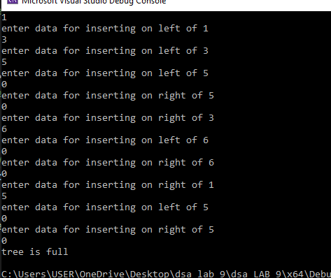
#include<iostream>
using namespace std;

class Btree {
public:
string Data;
Btree* leftChild;
Btree* rightChild;

Btree() {
Data = "";
leftChild = NULL;
rightChild = NULL;
}
Btree(string d) {
Data = d;
leftChild = NULL;
rightChild = NULL;
}

~Btree() {
delete leftChild;
delete rightChild;
}
};

bool checkFull(Btree* Node) {
if (Node == NULL) {
return true;
}

if ((Node->leftChild && !Node->rightChild) || (!Node->leftChild && Node->rightChild)) {
return false;
}

return checkFull(Node->leftChild) && checkFull(Node->rightChild);
}

Btree* buildTree() {
string d;
cin >> d;

if (d == "0") {
return NULL;
}

Btree* root = new Btree(d);

cout << "enter data for inserting on left of " << d << endl;
root->leftChild = buildTree();

cout << "enter data for inserting on right of " << d << endl;
root->rightChild = buildTree();

return root;
}

int main() {
Btree* tre = buildTree();
if (checkFull(tre)) {
cout << "tree is full \n";
}
else
cout << "its not full \n";

return 0;
}

Task 3 B:
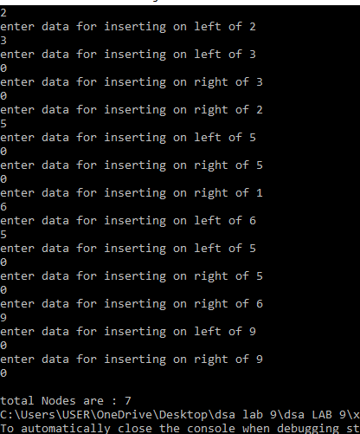

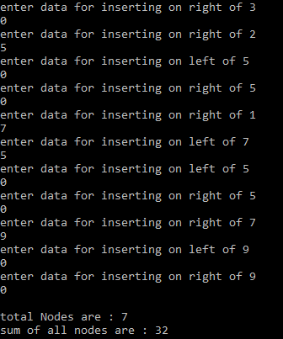
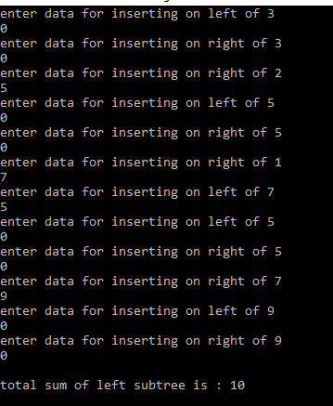
#include<iostream>
using namespace std;

int num = 0;
int sum = 0;
int Lsum = 0;

class btree {
public:
int data;
btree* leftchild;
btree* rightchild;

btree() {
data = -1;
leftchild = NULL;
rightchild = NULL;
}
btree(int d) {
data = d;
leftchild = NULL;
rightchild = NULL;
}

~btree() {
delete leftchild;
delete rightchild;
}
};

int coutAllNodes(btree* Node) {
if (Node == NULL)
return 0;
sum += Node->data;
++num;
coutAllNodes(Node->leftchild);

coutAllNodes(Node->rightchild);

return sum;
}

int LeftSum(btree* Node) {
Lsum = coutAllNodes(Node->leftchild);
return Lsum;
}

btree* buildtree() {
int d;
cin >> d;

if (d == 0) {
return NULL;
}

btree* root = new btree(d);

cout << "enter data for inserting on left of " << d << endl;
root->leftchild = buildtree();

cout << "enter data for inserting on right of " << d << endl;
root->rightchild = buildtree();

return root;
}

int main() {
btree* tre = buildtree();

coutAllNodes(tre);

cout <<"\ntotal Nodes are : " << num;
cout << "\nsum of all nodes are : " << sum;
cout << "\ntotal sum of left subtree is : " << LeftSum(tre);

cout << endl;
return 0;
}

